Assessment Schedule – 2016

Chemistry: Demonstrate understanding of bonding, structure, properties and energy changes (91164)
Evidence Statement

Q | Evidence | Achievement | Merit | Excellence
ONE  (a) | Endothermic  The temperature decreased OR heat / energy has been absorbed. | - Correct term with relevant reason in (a) OR (b).
(b) | Exothermic.  The enthalpy of the reaction is negative / energy has been released.
(c)(i)  (ii)  (iii) | Energy is required to change pentane from a liquid to a gas. The energy / heat is used to break weak intermolecular forces / bonds / attraction between pentane molecules.  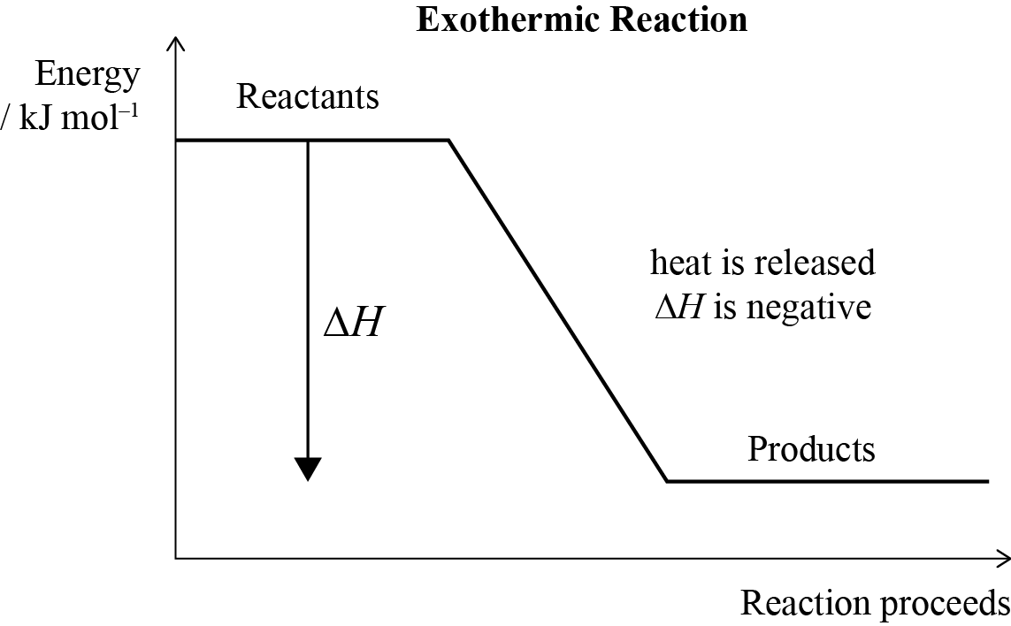  n (pentane) = 125 g / 72.0 g mol^{–1} = 1.74 mol  n (hexane) = 125 g / 86.0 g mol^{–1} = 1.45 mol  If 1 mole of pentane releases 3509 kJ energy, then 1.74 mol of pentane  1.74 × 3509 = 6106 kJ energy released.  If 2 moles of hexane release 8316 kJ energy,  then 1 mole of hexane releases 4158 kJ energy. So 1.45 mol of hexane  1.45 × 4158 = 6029 kJ energy releases.  So pentane releases more energy (77.0 kJ) than hexane, per 125 g of fuel. | - Identifies energy / heat is required / absorbed / taken in.  - Diagram correctly drawn, but not labelled.  - Amount (moles) of pentane or hexane correct. | - Explains that energy / heat is required / absorbed for breaking (intermolecular) forces / bonds / attractions.  - Diagram correctly drawn, but not fully labelled.  - Pentane or hexane calculation correct. | - Explains that energy / heat is required / absorbed for breaking (intermolecular) forces / bonds / attractions.  AND  Diagram correctly drawn and fully labelled.  - Both pentane and hexane calculations with units are correct, and identifies pentane as releasing more energy (link back to question) per 125 g of fuel.

NØ | N1 | N2 | A3 | A4 | M5 | M6 | E7 | E8
No response;  no relevant evidence. | 1a | 2a | 3a | 4a | 2m | 3m | 1e | 2e

Q | Evidence | Achievement | Merit | Excellence
TWO  (a) |  | - One row or one column correct.
  Substance | Type of substance | Type of particle | Attractive forces between particles
  ZnCl₂(s)  (zinc chloride) | ionic | ions | ionic
  C(s)  (graphite) | covalent network | atoms | covalent
  CO₂(s)  (carbon dioxide / dry ice) | molecular | molecules | intermolecular
(b) | Electrical conductivity depends on the presence of charged particles that are free to move.  Graphite is a covalent network substance made up of carbon atoms covalently bonded to 3 other carbon atoms. This leaves one valence non-bonded / delocalised electron from each carbon atom. These electrons are free to move and so graphite is able to conduct electricity.  ZnCl₂ is an ionic compound that cannot conduct electricity when solid because the ions (charged particles) are fixed in place in a 3D lattice structure and unable to move. When molten, the ionic bonds between the ions break, so the ions are free to move in the molten liquid. With charged particles / ions free to move, ZnCl₂ can then conduct electricity. | - Identifies that charged particles which are free to move are required for electrical conductivity.  - Identifies ZnCl₂(s) as not having ions / charges particles that are free to move  OR  identifies ZnCl₂(l) does have ions / charged particles that are free to move  OR  Identifies C(s) does have electrons / charged particles that are free to move. | - Explains conductivity by linking particles, structures, and bonding to either the conductivity of C (graphite)  OR  ZnCl₂ in both solid and liquid (molten) states. | - Justifies conductivity by relating particles, structures, and bonding to the conductivity of C (graphite)  AND  ZnCl₂ in both solid and liquid (molten) states.
(c) | Polar water molecules attract the ions in zinc chloride’s 3-D lattice strongly enough to separate and dissolve them. The negative charges on the oxygen ends of the water molecules are attracted to the positive Zn²⁺ ions, and the positive hydrogen ends of the water molecules are attracted to the negative Cl– ions, forming hydrated ions that can spread out through the solution.  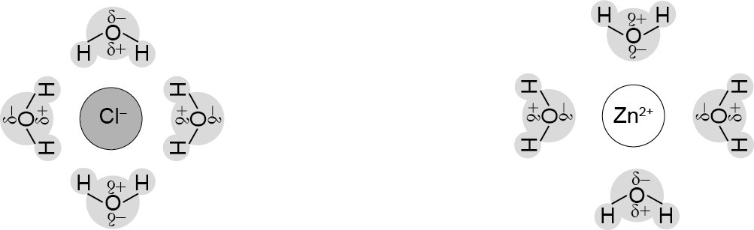  The polar water molecules are unable to interact with the non-polar carbon dioxide molecules strongly enough to break the intermolecular forces between the carbon dioxide molecules. | - Identifies attractions are needed between water and the substance for it to be soluble. | - Links relative strengths of attractions of the substance to water for the solubility of ONE of the substances. | - Justifies solubility by linking particles, structure, and bonding for both ZnCl₂ and CO₂.

NØ | N1 | N2 | A3 | A4 | M5 | M6 | E7 | E8
No response;  no relevant evidence. | 1a | 2a | 3a | 4a | 1m | 2m | 1e | 2e

Q | Evidence | Achievement | Merit | Excellence
THREE  (a)(i)  (ii) | 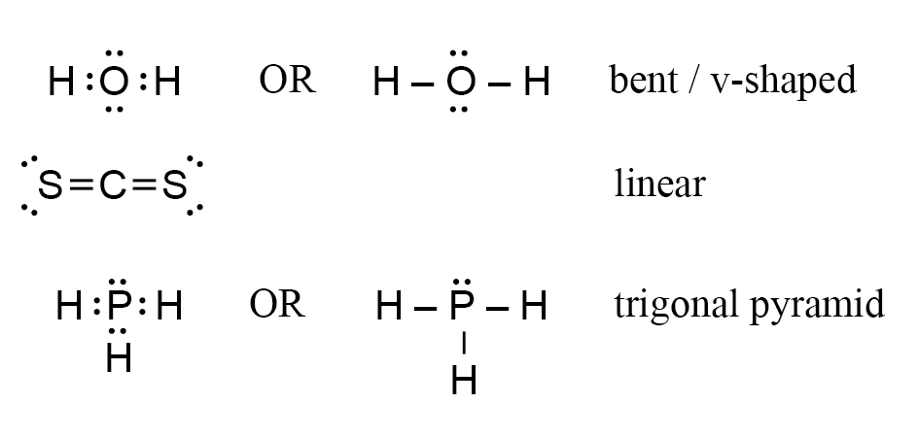  Bond angle is determined by the number of electron clouds / areas of negative charge around the central atom, which are arranged to minimise repulsion / are arranged as far apart from each other as possible (maximum separation).  Both H₂O and PH₃ have 4 electron clouds / areas of negative charge around the central atom, so the bond angle is that of a tetrahedral arrangement of 109.5°, whereas there are only 2 electron clouds / areas of negative charge around the central atom in CS₂, which means minimum repulsion is at 180°, resulting in CS₂’s shape being linear.  The shapes of H₂O and PH₃ differ despite having the same tetrahedral arrangement because water has two non-bonding pairs of electrons around the central atom, while phosphine only has one non-bonding pair. The resulting shapes are bent or v-shaped for H₂O, while PH₃ is trigonal pyramid. | - Two Lewis structures (electron dot diagrams) correct.  AND  Two shapes correct.  - Identifies the numbers of electron clouds / regions of negative charge around the central atoms for TWO molecules.  OR  Identifies non-bonding pairs and bonding pairs of electrons on the central atoms for TWO molecules. | - Links areas of negative charge around the central atom to minimise repulsion (maximum separation) and bond angles for TWO molecules. | - Compares and contrasts the bond angle and shapes of all three molecules by referring to electron repulsion, areas of negative charge / electron clouds and bonding / non-bonding electrons.
(b) | Each N-H bond in NH₃ is polar / forms a dipole because the N and H atoms have different electronegativities. The shape of the molecule (due to the presence of one non-bonding electron pair) is trigonal pyramidal which is asymmetrical, so the dipoles / bond polarities do not cancel. The resulting NH₃ molecule is polar.  Each B-H bond in BH₃ is polar / forms a dipole because the B and H atoms have different electronegativities. The shape of the molecule is trigonal planar which is symmetrical, so the dipoles / bond polarities cancel. The resulting BH₃ molecule is non-polar. | - Identifies that the atoms within the bonds have different electronegativities. | - Links bond polarity to electronegativity differences between atoms for one molecule  OR  Uses symmetry to link molecule polarity to bond dipoles cancelling / not cancelling for 1 molecule. | - Justifies polarity of ammonia and borane referring to differences in electronegativity, dipoles, and symmetry (shape) of molecules.
(c) | Bond breaking Bond making  C=C 614 C–C × 3 1038  C–C × 2 692 C–H × 10 4140  C–H × 8 3312 5178 kJ mol^{–1}  H–H 436  5054 kJ mol^{–1}  Δ_{r}H° = Bond breaking – bond making  Δ_{r}H° = 5054 kJ mol^{–1} – 5178 kJ mol^{–1}  Δ_{r}H° = –124 kJ mol^{–1}  OR  Bond breaking Bond making  C=C 614 C–C 346  H–H 436 C–H × 2 414 × 2  1050 kJ mol^{–1} 1174 kJ mol^{–1}  Δ_{r}H° = Bond breaking – bond making  Δ_{r}H° = 1050 – 1174  Δ_{r}H° = –124 kJ mol^{–1} | - Identifies the two relevant bonds broken (C = C and  H – H). | - Correct process with minor errors. Identifies which bonds are broken and which bonds are formed. | - Correct answer, including correct sign and unit.

NØ | N1 | N2 | A3 | A4 | M5 | M6 | E7 | E8
No response;  no relevant evidence. | 1a | 2a | 3a | 4a | 2m | 3m | 2e | 3e

Cut Scores
Not Achieved | Achievement | Achievement with Merit | Achievement with Excellence
0 – 6 | 7 – 13 | 14 – 19 | 20 - 24

